JBoss BPM Suite - BAM Dashboard

This is a Business Activity Monitoring (BAM) component is going to be part of JBoss BPM Suite, which allows you to connect to various datasources. Allow you to monitor the real time information about the status of business activities happening in JBoss BPM.

This version of BAM is not yet fully integrated with BPM yet. And will still have many more function coming in the near future.

Environment Setting

Installing JDK
To verify that this is correct you will have to look at these values on your system One simple way to check the JDK version that you have is to run:

java –version
java version "1.6.0_51"
Java(TM) SE Runtime Environment (build 1.6.0_51-b11-457-11M4509)
Java HotSpot(TM) 64-Bit Server VM (build 20.51-b01-457, mixed mode)

See if it is JDK 1.6 or above.

Installing Postgresql Database:
Please download postgresql from: http://www.postgresql.org/download/ and install the database.

Installation

Goal
Install JBoss BPM Suite, BAM Dashboard.

Pre-requisites
JDK 1.6, version 16 or later

Software

- bpms-bam-dashboard.zip
- jboss-eap-6.1.0.zip

Installation Steps
1. You have already cloned the project to your computer or you would not be reading this guide, you will see a folder name: bpms-bam-dashboard.
Inside folder bpms-bam-dashboard, you will see the following files and directories of note:
- installs – Place to hold zipped JBoss EAP 6.1 file.
- projects – Placeholder for project code, unused in this demo.
- support – Where the BAM and supporting configuration files are found
  - windows – contains scripts for windows, see support README for details.
- README.md – Read Me file for installation.
- init.sh – installation script.
- Demo Overview BAM.{odp|pdf} – architectural overview of demo.
- BAM lab guide.{odt|pdf} – this guide.
2. Place your jboss-eap-6.1.0.zip into the installs directory, if you are running Linux, make sure this file is executable. running chmod +x <path-to-project>/installs/jboss-eap-6.1.0.zip
Install BAM Dashboard by running
- For Linux and Mac:
  - /init.sh
- For Windows:
  - support/windows/init.bat
3. You should see a folder target created. Now we are going to add users for BAM. Go to target/jboss-eap-6.1/bin
- For Linux and Mac:
  - ./add-user.sh
- For Windows:
  - add-user.bat

Add root to management user with your preferred password.
Add christina (or your choice) to with your preferred password, assign groups “user,admin” to this user.

$ ./add-user.sh

What type of user do you wish to add?
a) Management User (mgmt-users.properties)
b) Application User (application-users.properties)
(a):
Enter the details of the new user to add.
Realm (ManagementRealm) :
Username : root
The username 'root' is easy to guess
Are you sure you want to add user 'root' yes/no? yes
Password :
Re-enter Password :
About to add user 'root' for realm 'ManagementRealm'
Is this correct yes/no? yes
Added user 'root' to file '/Users/christina/Desktop/BPM-BAM/bpms-bam-dashboard-master/target/jboss-eap-6.1/standalone/configuration/mgmt-users.properties'
Added user 'root' to file '/Users/christina/Desktop/BPM-BAM/bpms-bam-dashboard-master/target/jboss-eap-6.1/domain/configuration/mgmt-users.properties'
Is this new user going to be used for one AS process to connect to another AS process?
e.g. for a slave host controller connecting to the master or for a Remoting connection for server to server EJB calls.
yes/no? no

$ ./add-user.sh

What type of user do you wish to add?
a) Management User (mgmt-users.properties)
b) Application User (application-users.properties)
(a): b

Enter the details of the new user to add.
Realm (ApplicationRealm) :
Username : christina
Password :
Re-enter Password :
What roles do you want this user to belong to? (Please enter a comma separated list, or leave blank for none)[ ]: user,admin
About to add user 'christina' for realm 'ApplicationRealm'
Is this correct yes/no? yes
Added user 'christina' to file '/Users/christina/Desktop/BPM-BAM/bpms-bam-dashboard-master/target/jboss-eap-6.1/standalone/configuration/application-users.properties'
Added user 'christina' to file '/Users/christina/Desktop/BPM-BAM/bpms-bam-dashboard-master/target/jboss-eap-6.1/domain/configuration/application-users.properties'
Added user 'christina' with roles user,admin to file '/Users/christina/Desktop/BPM-BAM/bpms-bam-dashboard-master/target/jboss-eap-6.1/standalone/configuration/application-roles.properties'
Added user 'christina' with roles user,admin to file '/Users/christina/Desktop/BPM-BAM/bpms-bam-dashboard-master/target/jboss-eap-6.1/domain/configuration/application-roles.properties'
Is this new user going to be used for one AS process to connect to another AS process?
e.g. for a slave host controller connecting to the master or for a Remoting connection for server to server EJB calls.
yes/no? no

4. Go to target/jboss-eap-6.1/bin and start up JBoss EAP server
- For Linux and Mac : .
  - /standalone.sh
- For Windows:
  - standalone.bat
5. Go to http://localhost:8080/dashbuilder/ in your browser. Login with your application user name and password.
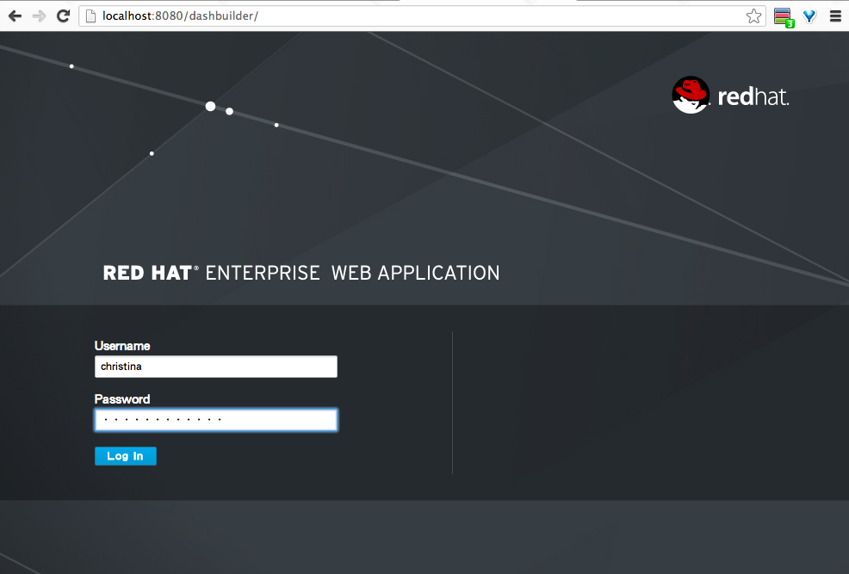
The dashboard is ready to roll, have fun with it.
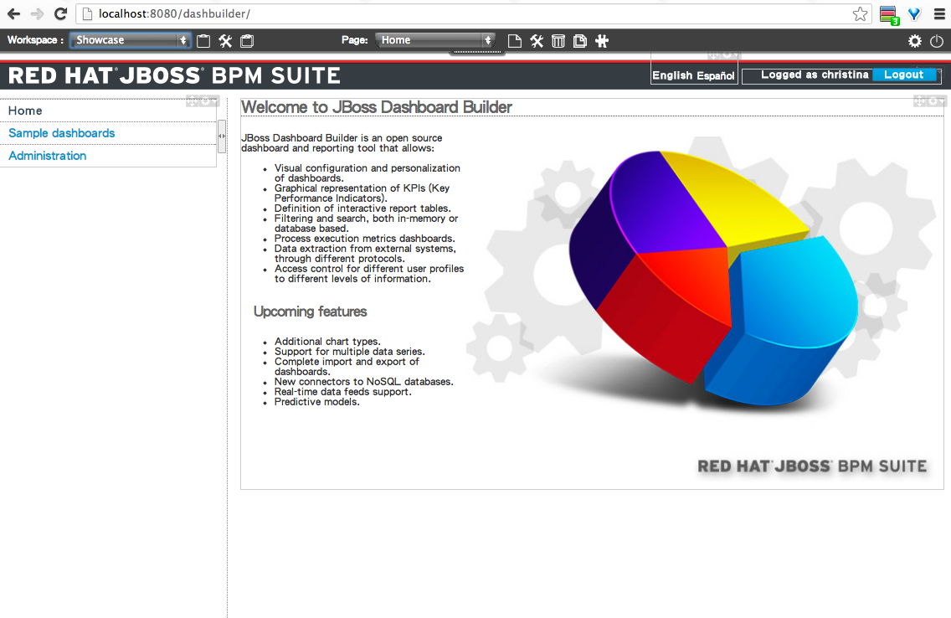

Walk Through

Goal
Adding an external Datasource to BAM
Go through BAM console , Adding a new page in BAM

Pre-requisites
- Finished installing BAM
- Install Postgresql Database to your machine (do-it-yourself exercise)
- Execute SeatTable.sql
  - psql -U username -d myDataBase -a -f SeatTable.sql

Administration
Go to the left menu and find Administration

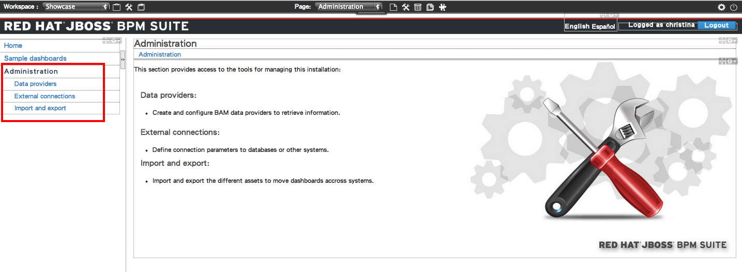

External Connection

1. Open file “support/postgresDS.cli”, change it’s value according to your database setting.
- db_url=jdbc:postgresql://localhost:5432/postgres
- db_username=postgres
- db_password=sibyl821

2. Make sure your JBoss EAP 6 instance is running, install DataSource by executing
- For Linux and Mac
  - support/installPostgres.sh
- For Windows
  - support/windows/installPostgres.bat

3. Check if the datasource is created by logging into Admin Console
http://localhost:9990/ with user root.
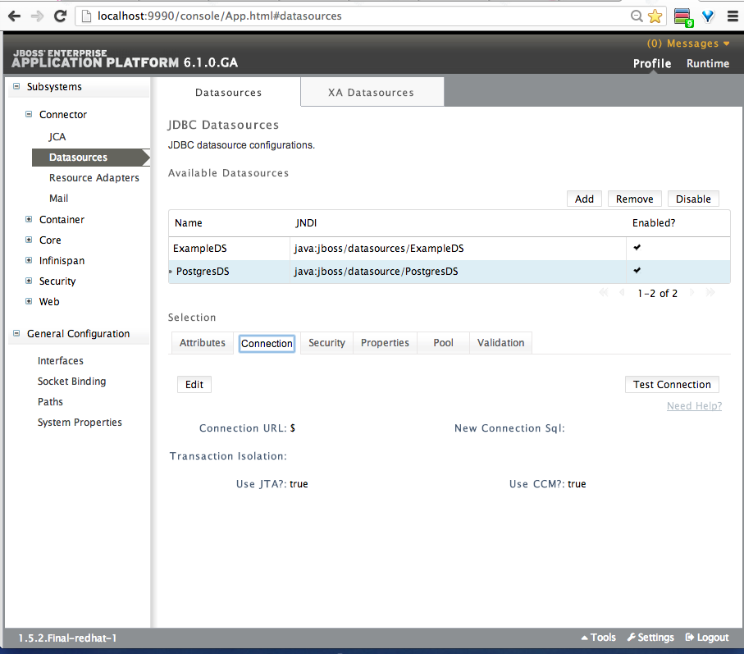

4. Open up External Connection by clicking the External Connection on the left
and fill in the following information

- Type: JNDI
- Name: PostgresDB
- JNDI Path: java:jboss/datasource/PostgresDS
- Test Query: select 1

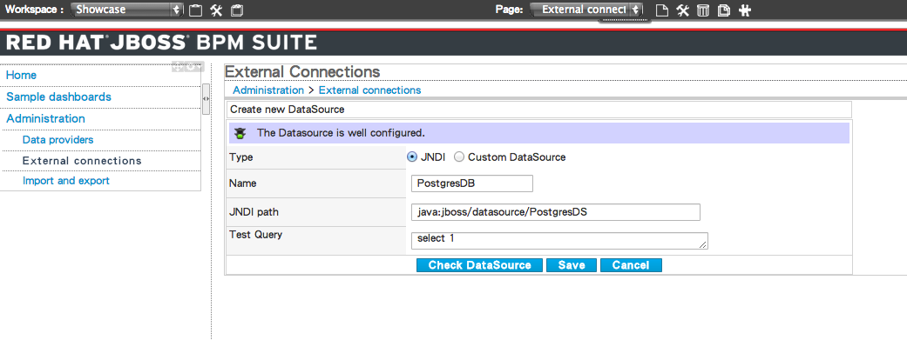

Click on “Check DataSource” to see if it created correctly and click Save if successful.

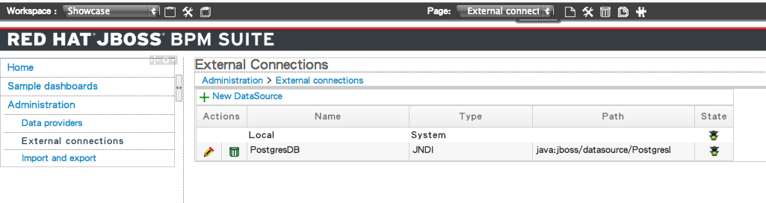

Data Provider
Within Data Provider Section, you will see the default 2 cvs file that is preinstalled

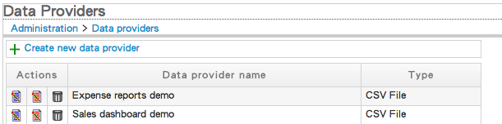

Now we are going to install a new data source select

- Type: SQL Query
- Name: Travel Seat
- DataSource: PostgresDB
- Query: select * from jbtravel.seat

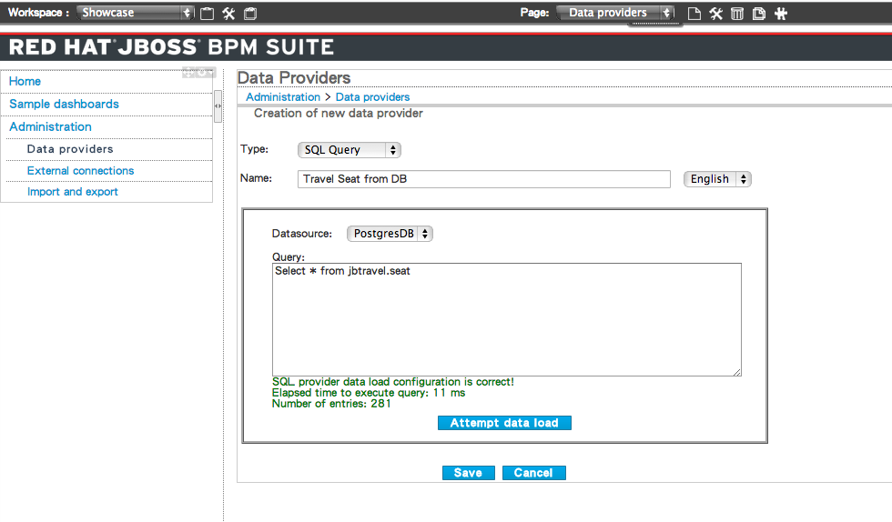
Click on Attempt data load to try and load data. Then click Save to save the setting. Set the column names to your desire name.
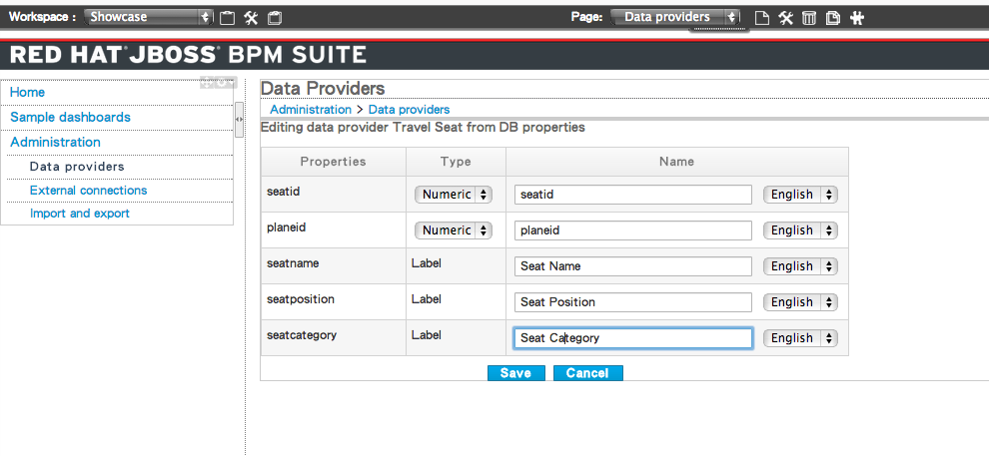
Click Save, then you have successfully created a Data Provider. We can later use this data source to create reports on dashboard.
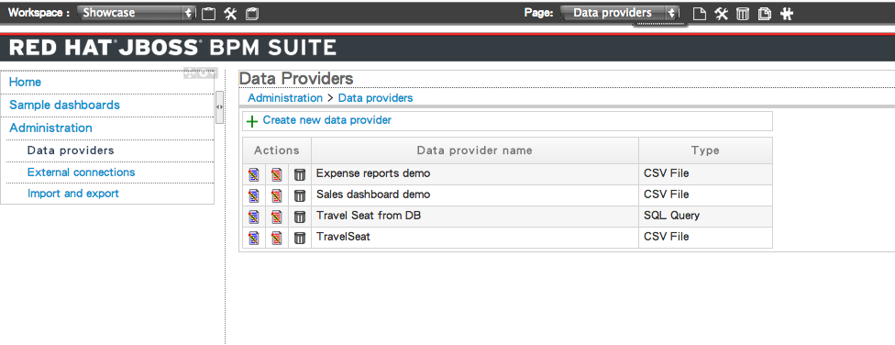

Dashboard
Default BAM come with two sample dashboards.
- Sales opportunity
- Expense report

Now we are going to create a new page within the default with the datasource we have just created.

1. Click on the top left icon (as shown below) to create a new workspace.
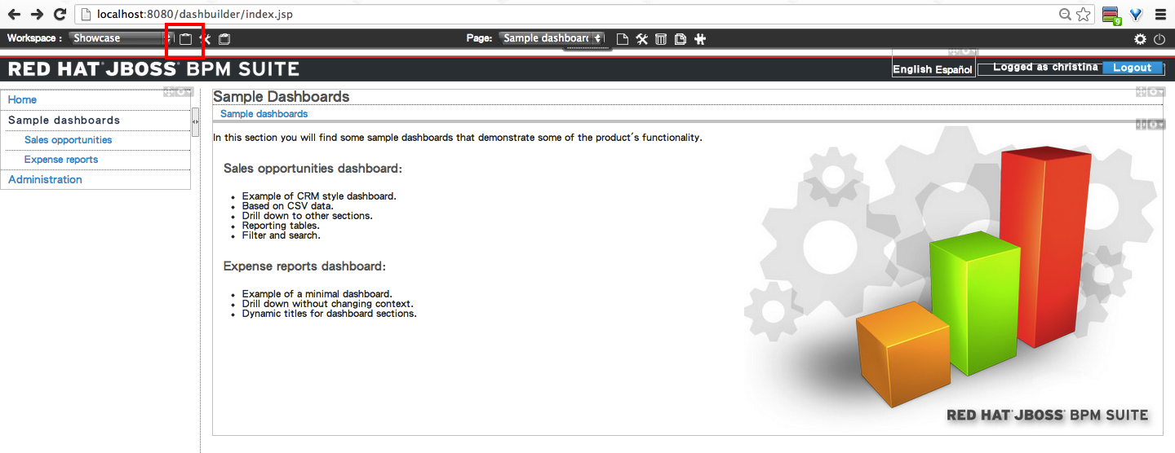

2. Fill in the New Workspace name and the title
Name: Demo (or any other name you liked)
Title: Airline Sear (or any other name you liked)

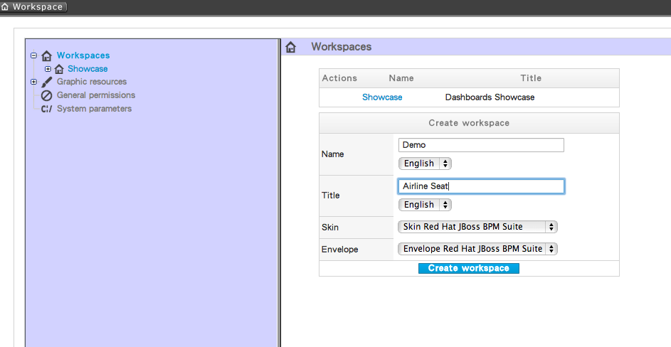
Click on Create workspace to save the setting

3. Create a new page by clicking on the create new page icon.
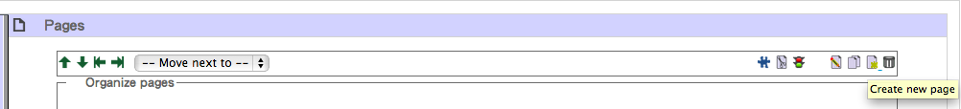
fill in the Title of the new page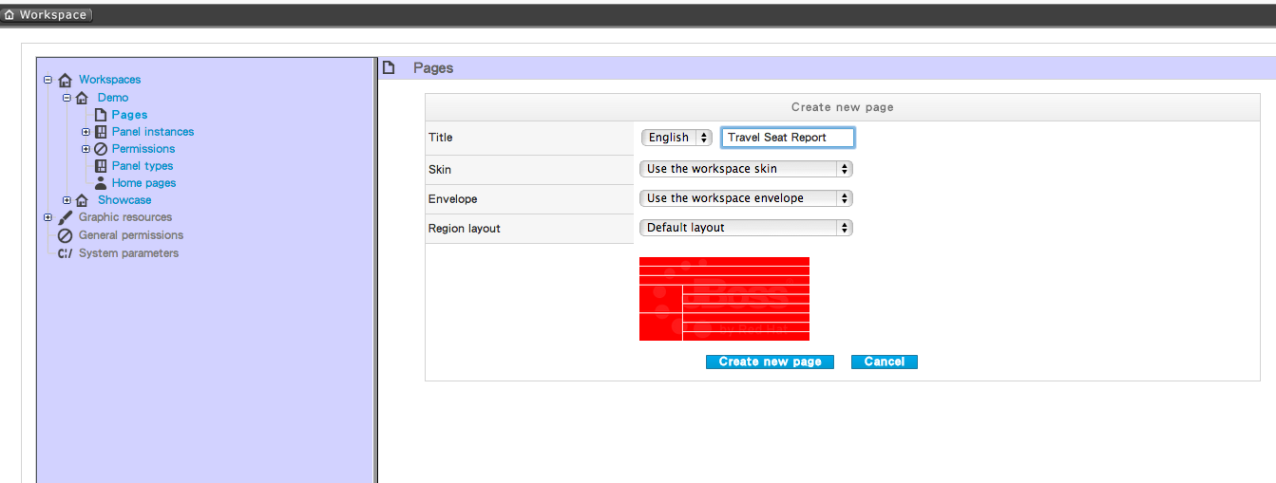

4. Go back to the workspace by clicking the top left hand workspace icon. And select the new page on the top center drop down menu, you should see a blank page.
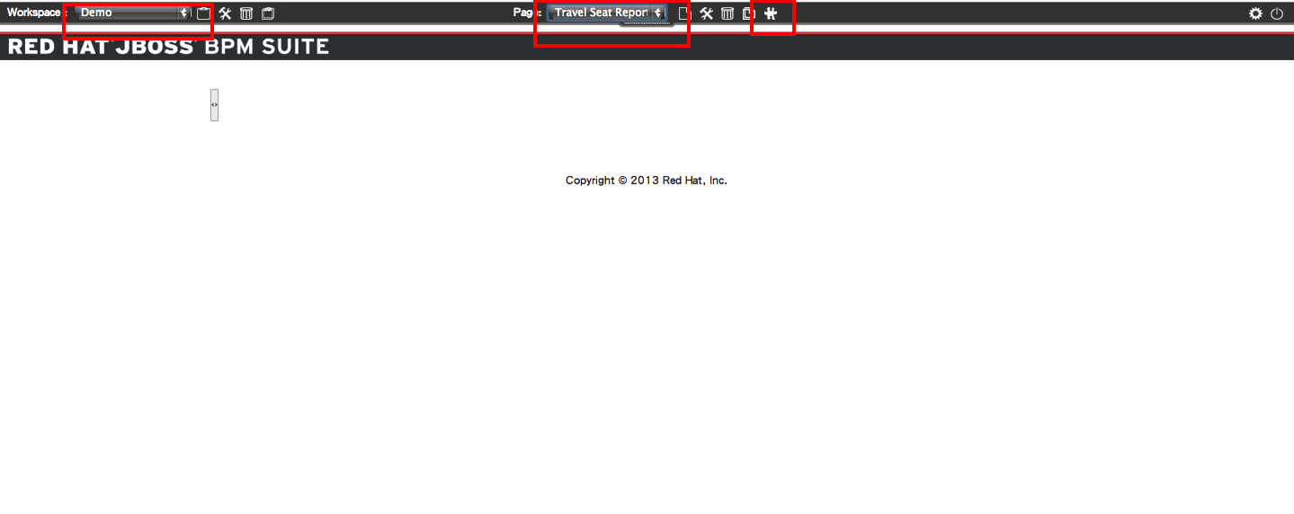
Click on the edit icon beside the drop down page menu. Should see a pop up box, displaying the available panel that can be added to the page.
5. Choose Navigation and select Tree menu.
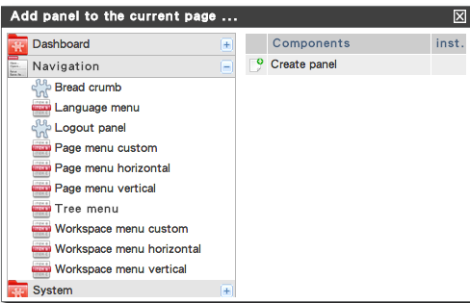
Click on the create panel, hold and drag it to left top region.
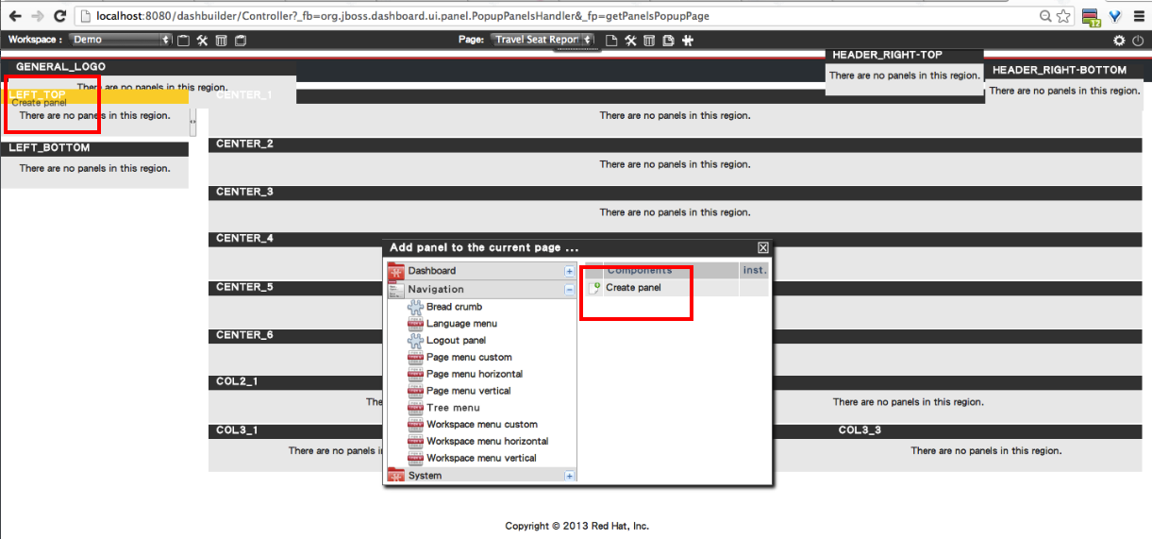
6. Create a Bar Report, click on the edit icon beside the drop down page menu, select Dashboard -> Key Performance Dashboard -> Create Panel, and drag it to CENTER_2
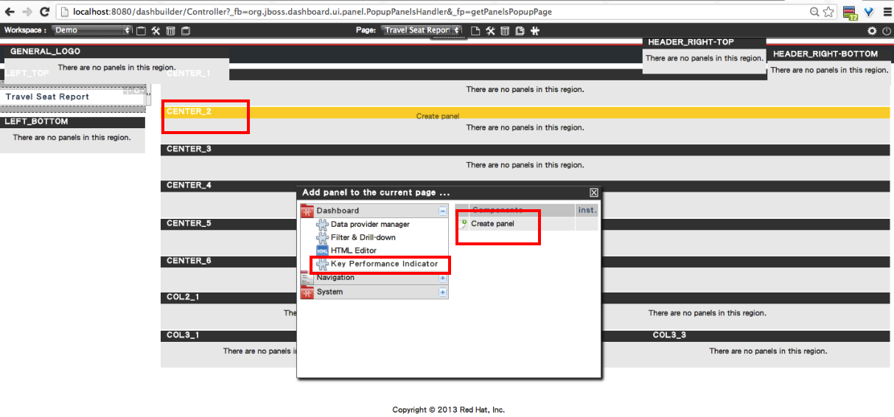
7. Select Travel Seat as our new panel data provider, add the
- Title: Seat Category Report
- Domain (X axis): Seat Category
- Show Label: tick the box
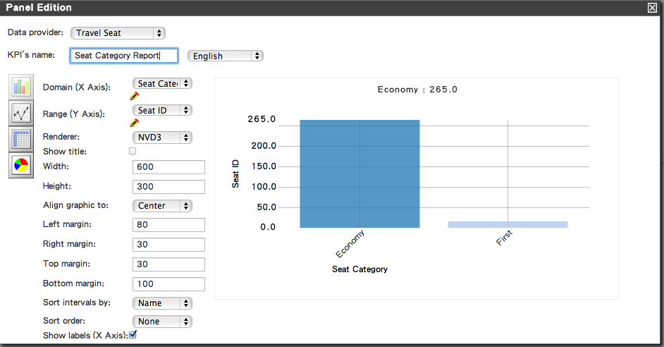
Click on the right left exit icon to exit editing.
8. Create a Pie graph, drag another new panel from Dashboard -> Key Performance Dashboard -> Create Panel, to CENTER_3 from the page.
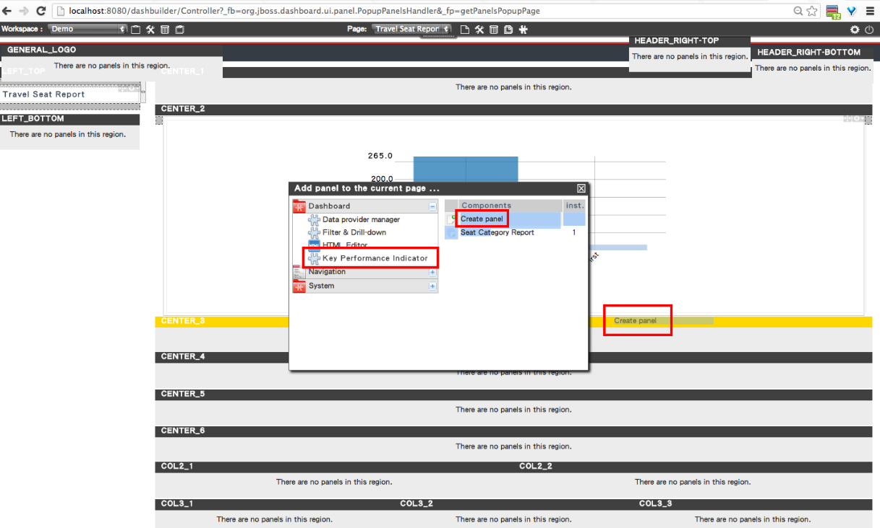
9. Select Travel Seat as our new panel data provider, click on the pie graph.
- Title: Seat Position Report
- Domain (X axis): Seat Position
- Show Legend: tick the box
- Show Title: tick the box

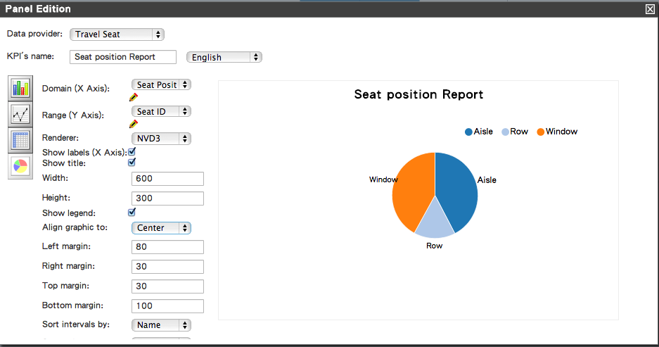
10. Create a Data Table, drag another new panel from Dashboard -> Key Performance Dashboard -> Create Panel, to CENTER_3 from the page.
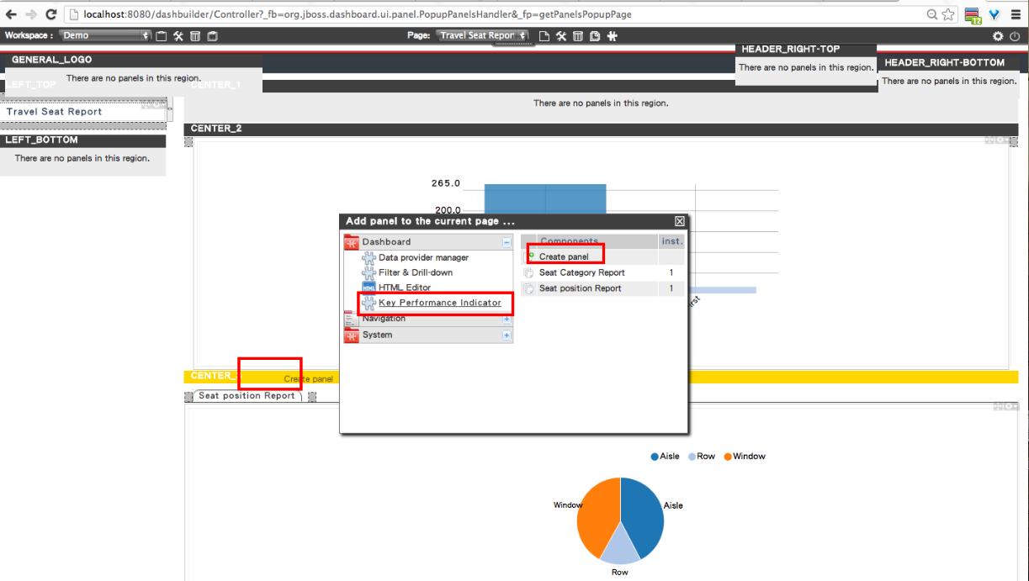
11. Select Travel Seat as our new panel data provider, click on the pie graph.
- Title: Seat Detail
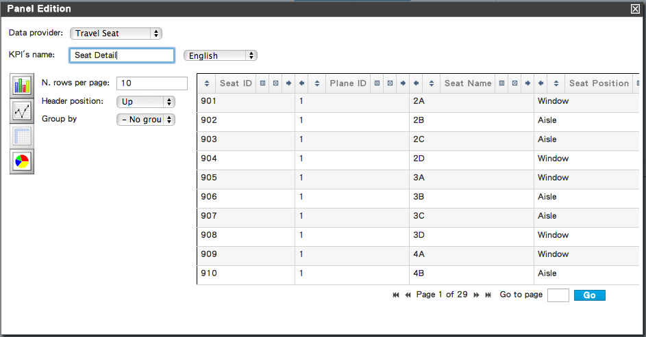
12. Create a filter, drag another new panel from Dashboard -> Filter & Drills -> Create Panel, to CENTER_3 from the page.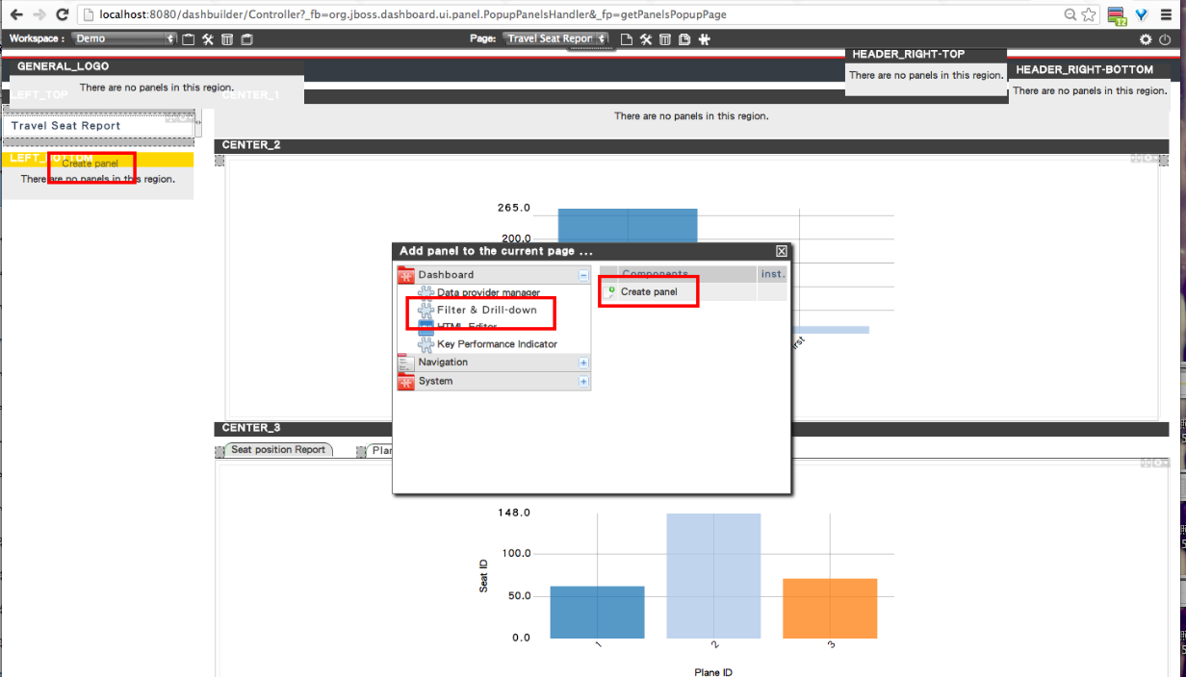
13. You will see a blank panel with “No properties added to the filter. Please, edit the panel and configure the filter's options properly” wording. Click on the filter icon. 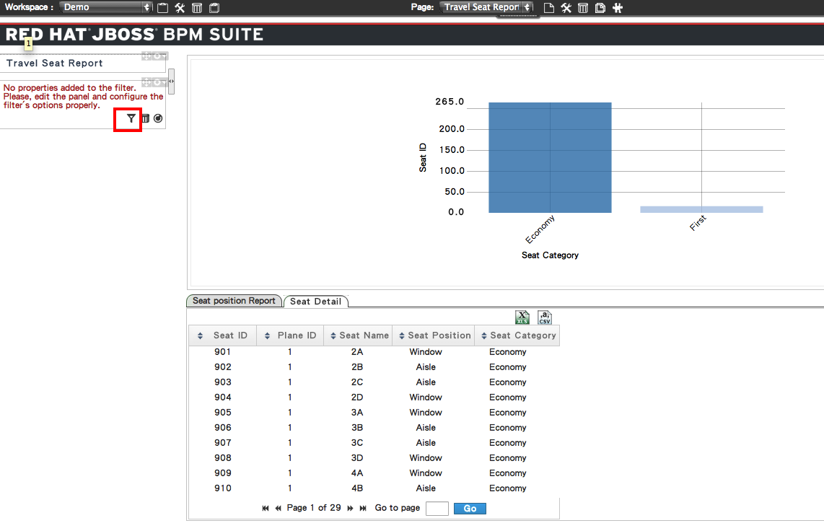
Click on the last three column to on the option
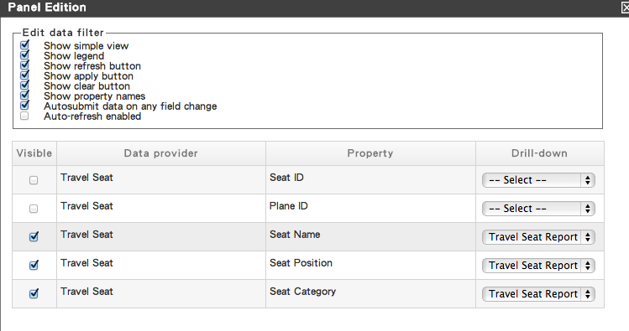

14. You have successfully created the Demo for this test page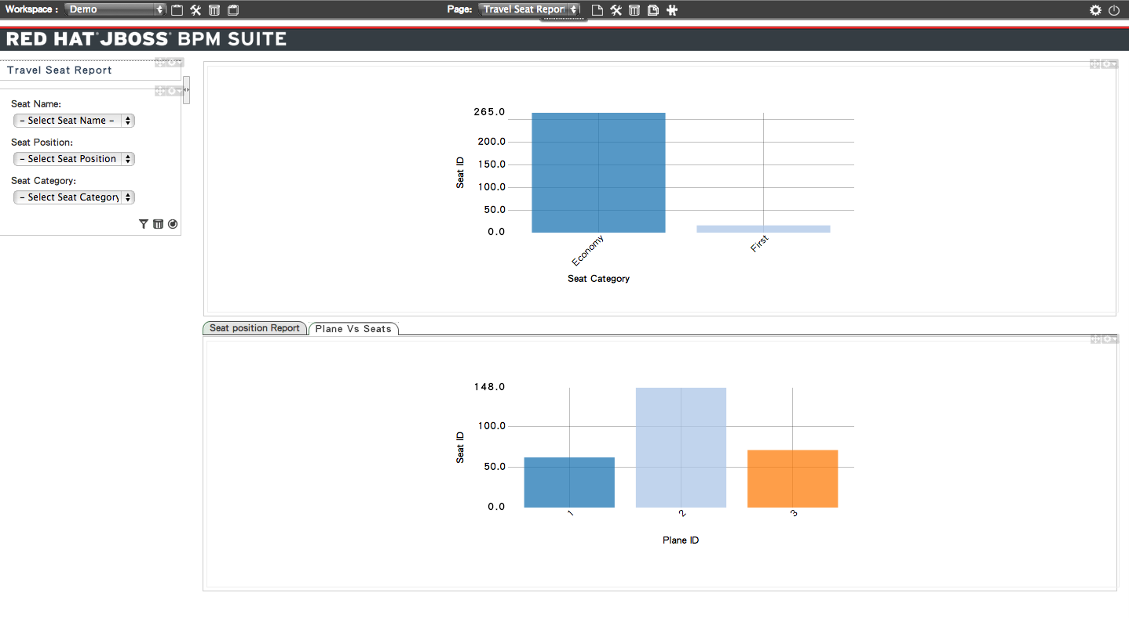
There are many more functions in JBoss BPM suite BAM. Allow you to monitor business activities in many different aspects. Have fun and play with it.

